SBA 8

Adithya K Prabhu - 211480

1. program to take input of two integer arrays from the user and to find the sum of both the arrays.

Sort the elements of the resultant array in ascending order using selection sort.

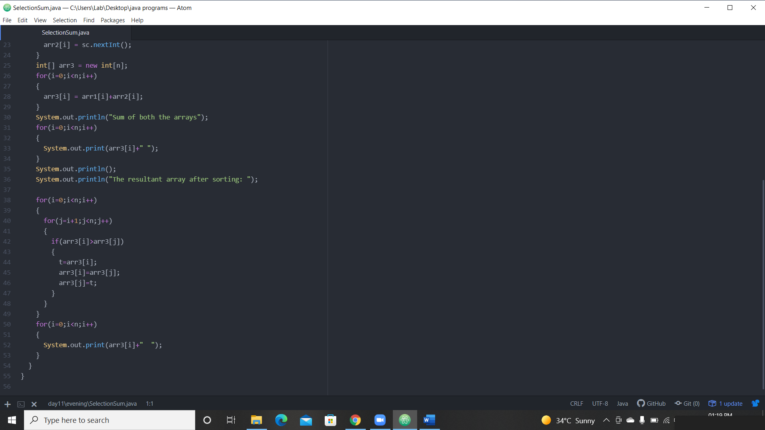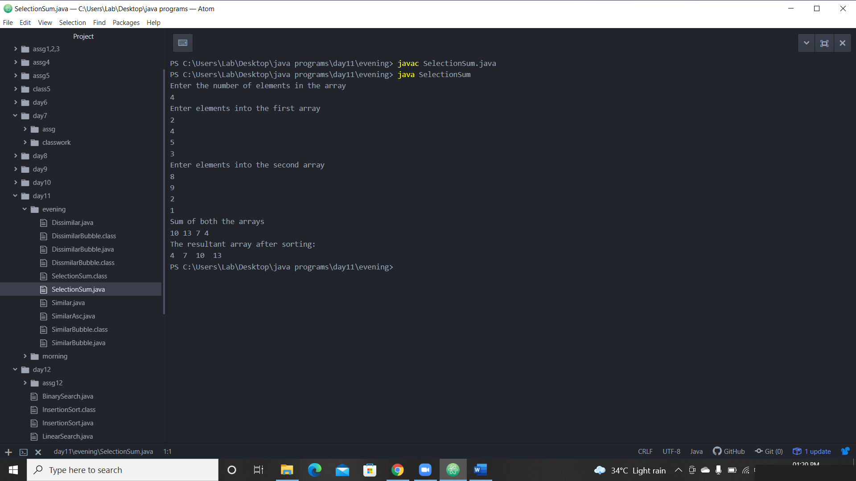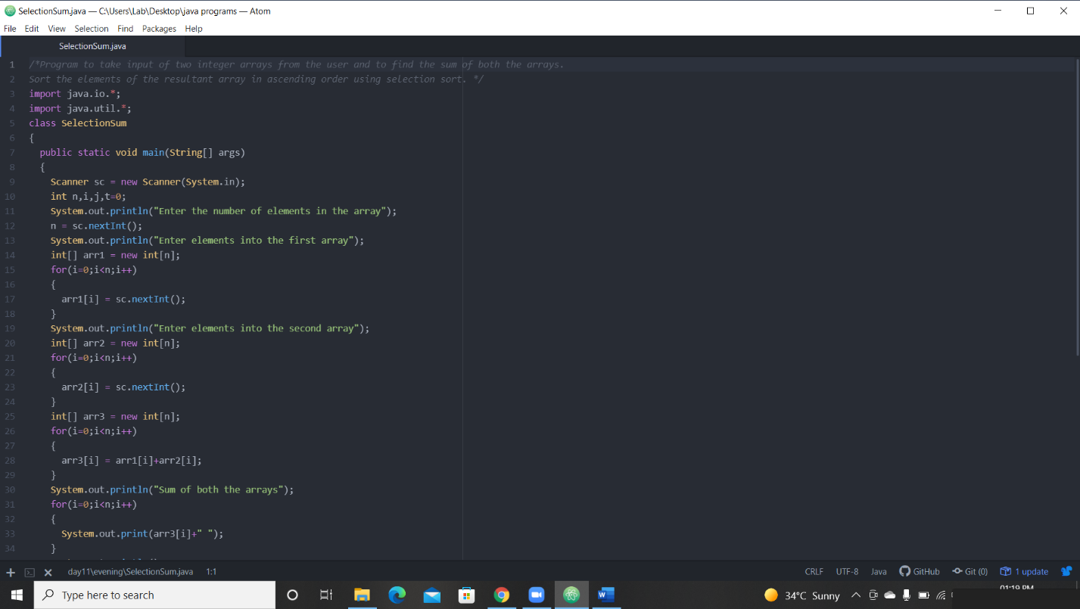

2. program to take input of Two arrays and store the similar elements into the resultant array.

 sort the resultant array in ascending order using bubble sort.

NOTE: there must at least be 6 similar elements.

similar elements= the elements occurring in both the arrays.

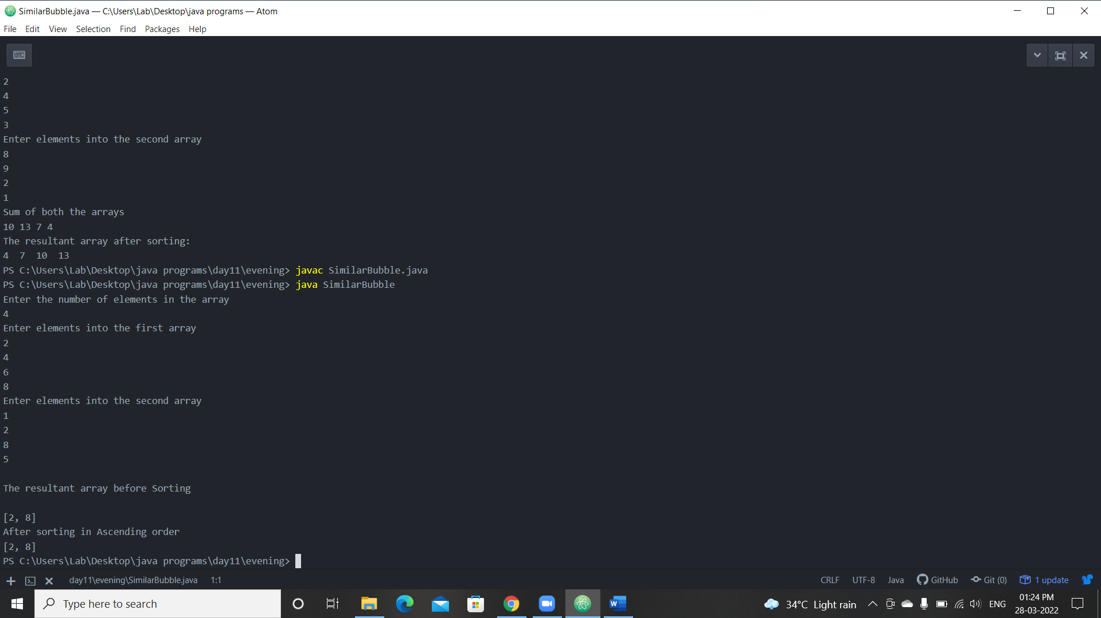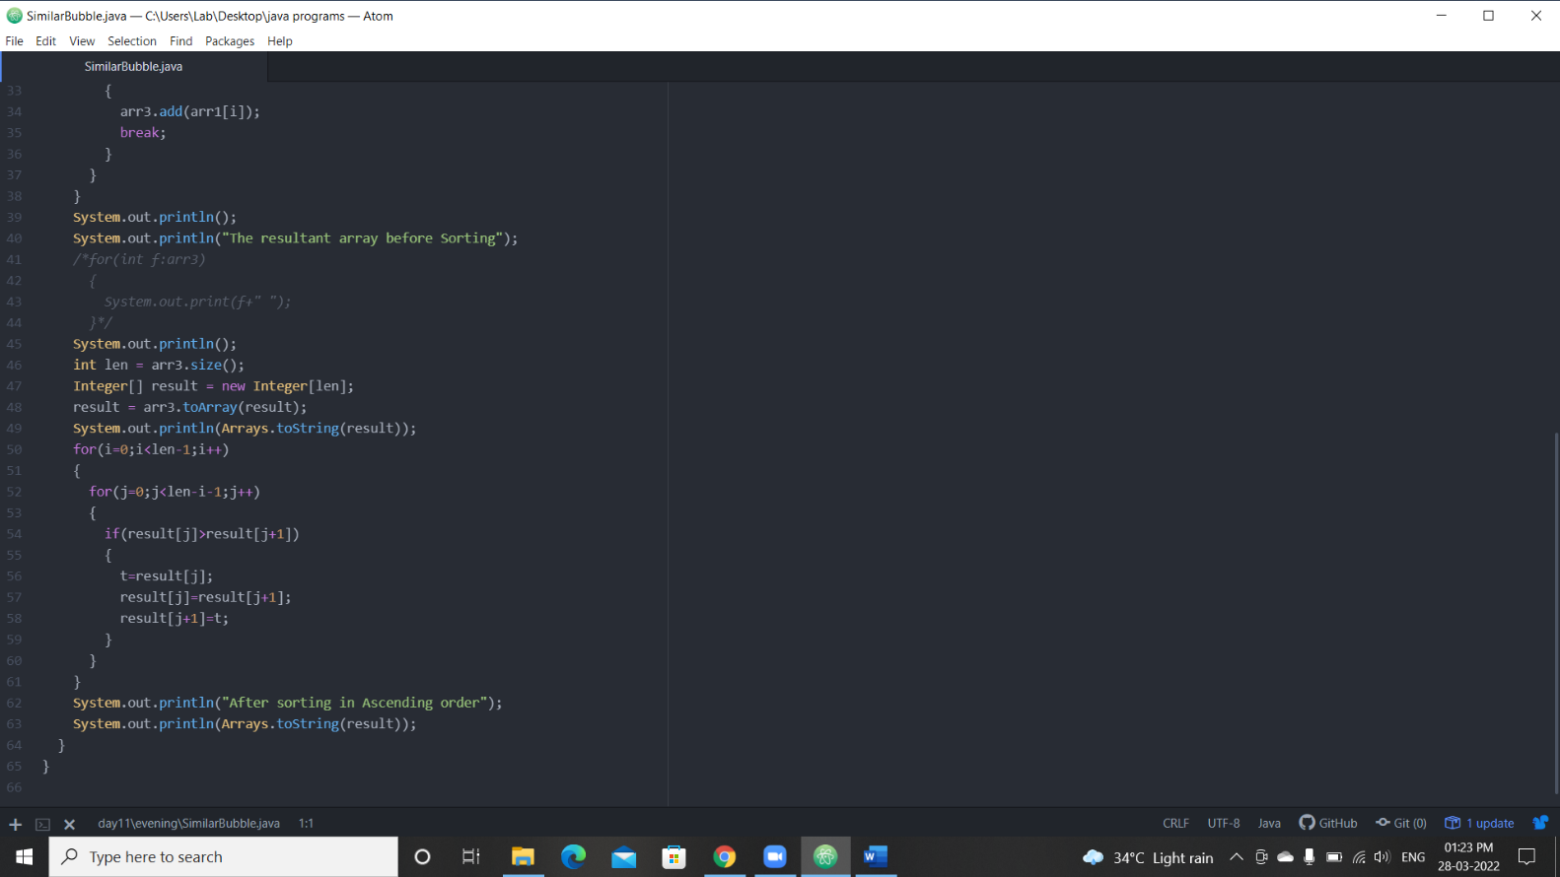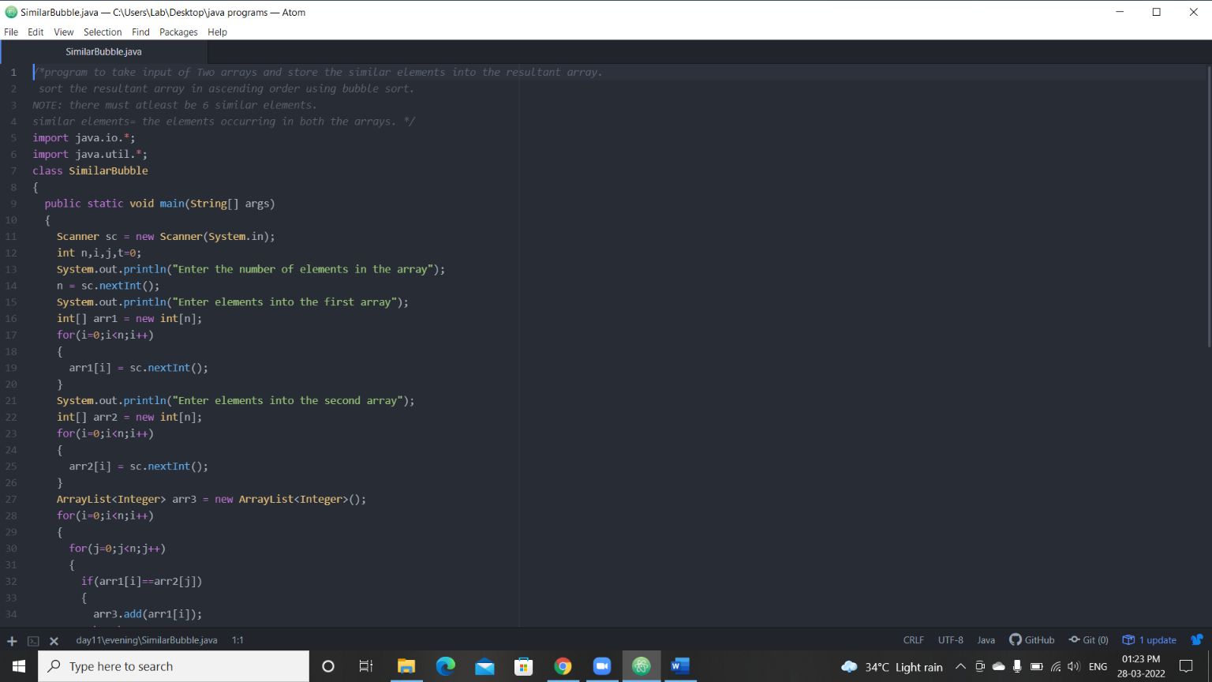

3.program to take input two arrays and store the dissimilar elements into a resultant array.

sort the resultant array in a descending order using bubble sort.

dissimilar elements= the elements not occurring in both the arrays.(unique elements)

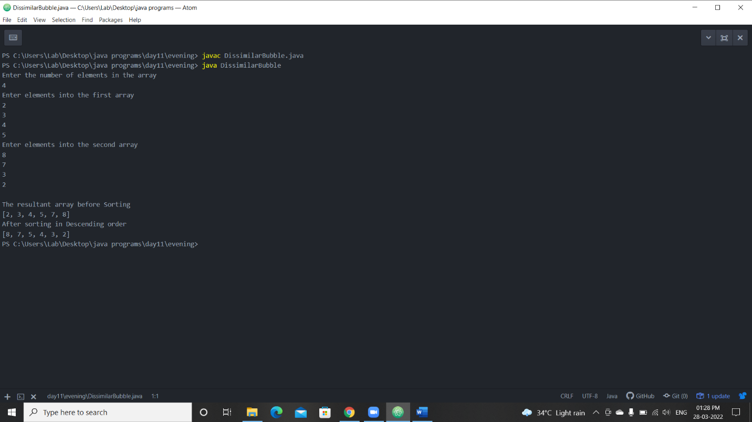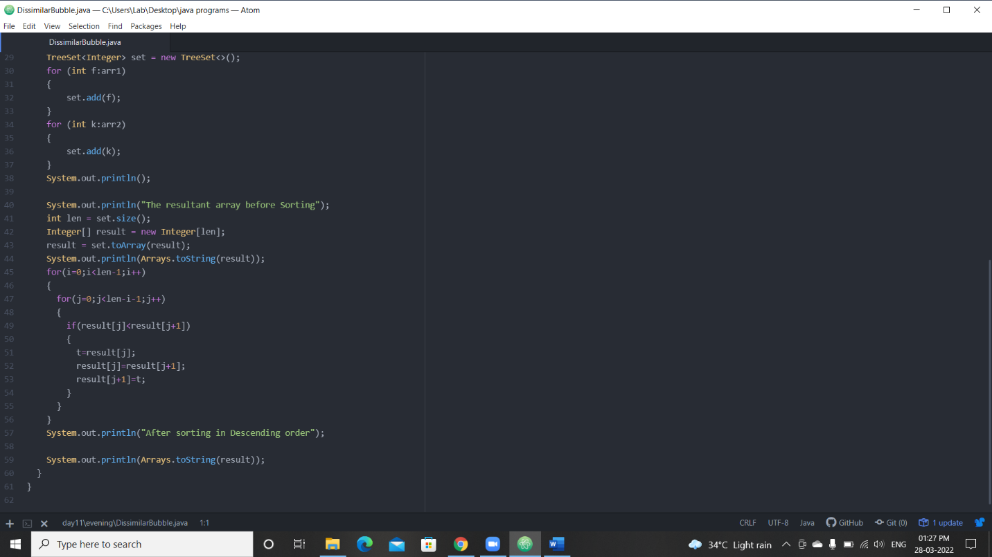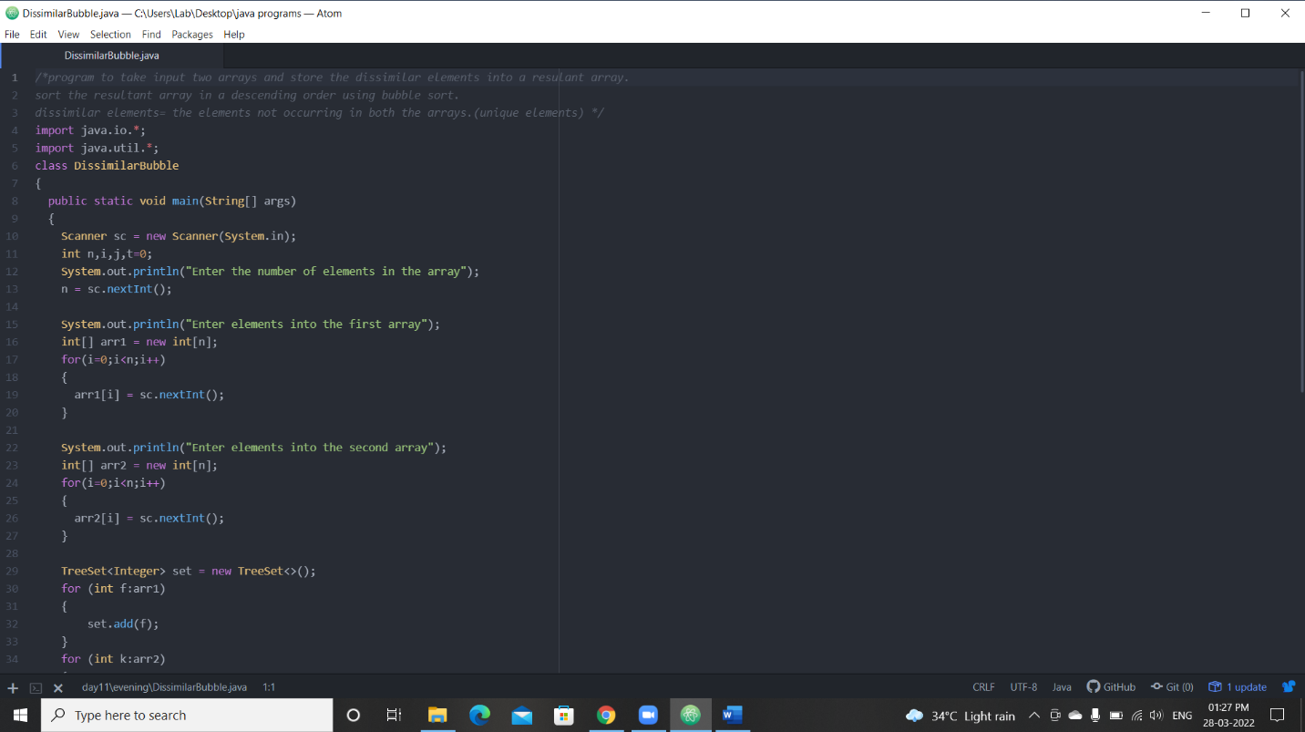

4. Implement Array List and add, remove, elements in the Array List and perform sorting of the elements.

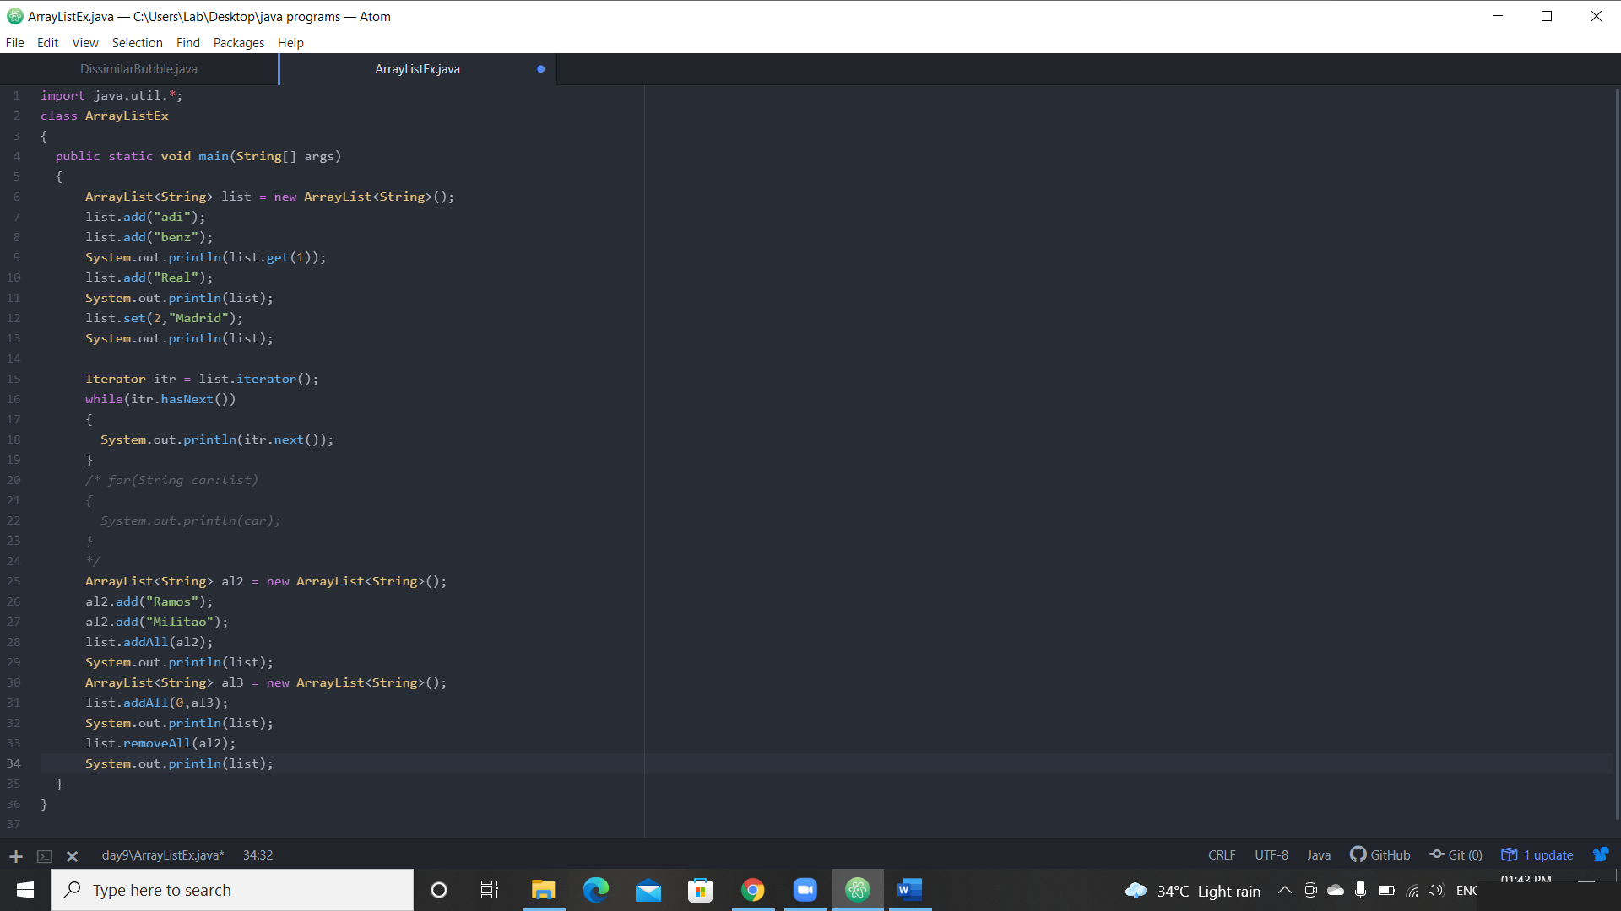

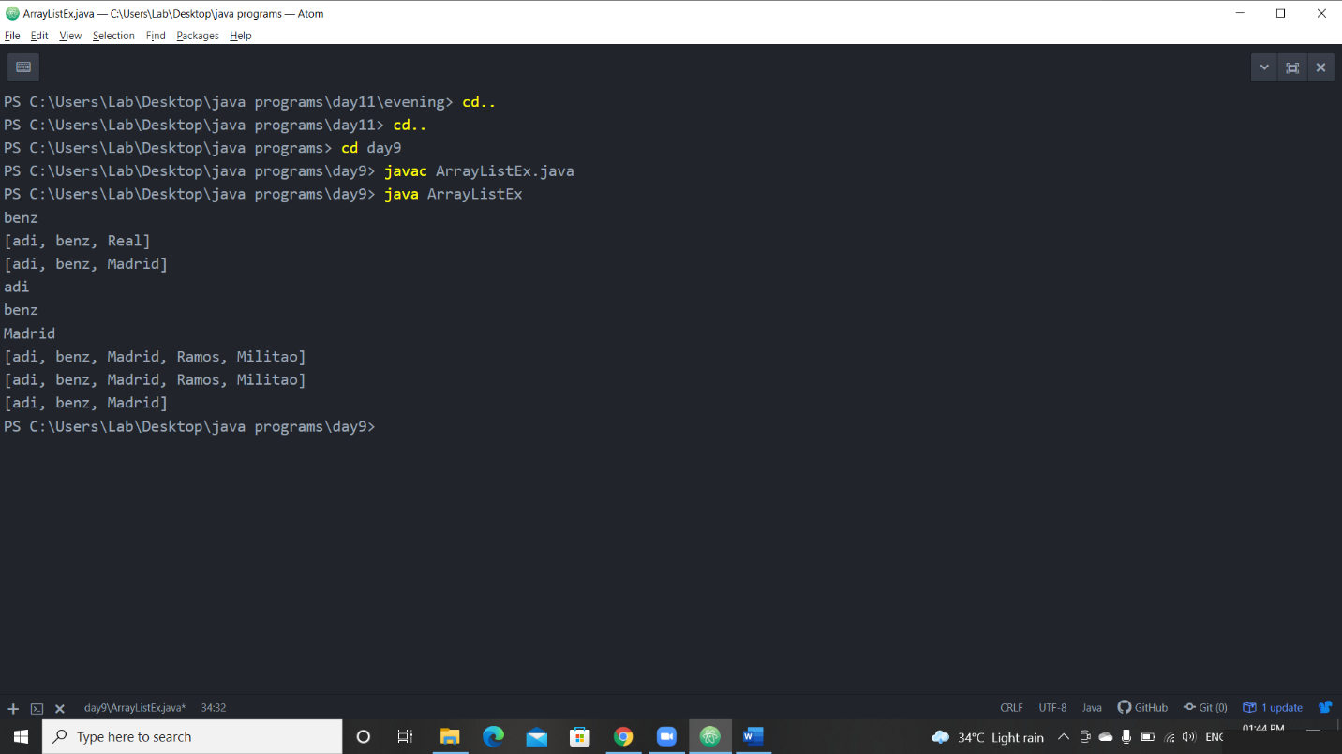

5. Implement LinkedList and add, remove, elements in the LinkedList and perform sorting of the elements.

